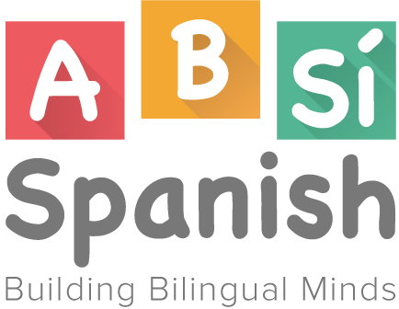
Job Opportunity
ABSi Spanish is currently seeking a qualified bilingual instructor to teach Spanish once or twice a week. Individuals who are on their way toward earning a degree and or have experience with working with children are preferred.
ABSi Spanish is a Spanish language enrichment program, created specifically for 3-6 year olds. The thematic, vocabulary building units teach academic and conversational Spanish using visual, auditory and kinesthetic activities. Classes are on hour long and take place once a week at different school sites. The staff at ABSi is highly energetic, loving and dedicated.
Job Description:
- Establish a positive, fun rapport with every child and family
- Learn and follow ABSi’s curriculum
- Teach a one hour class one to four times a week (flexible)
- Arrive 15 minutes prior to class start time for set up; leave once all students are properly dismissed
- Maintain communication with parents about their children via email
- Take care of teaching materials for the 3-4 week session
- Maintain a notebook with attendance information, lesson plans, parent contact info. Etc...
- Dress professionally
Compensation
- $13-$16 per hour. Includes driving to and from, setup, teaching and dismissal. Must have or apply for AZ Fingerprint Clearance Card

